**Engineering stress**, $σ=\frac{P(load)}{A_{0}}$**Engineering strain**, $ϵ=\frac{l-l_{0}}{l_{0}}=\frac{∆l}{l_{0}}$

**True stress** = $\frac{P\left(load\right)}{Ai}$ where Ai is the area at the instant when the load is applied.

The two are different in the way the test data is reported. **Engineering stress is always lower than true stress.**

|  |  |  |  |
| --- | --- | --- | --- |
|  | The engineering stress curve exhibits an inflection point when the cross-sectional area of the sample begins to decease (“necking”), which is **not** taken into account in the definition of engineering stress, which assumes a constant (original) area. There can be no inflection point in the true stress because each increment of area reduction is included in the definition.  Both true stress and true strain add incrementally as deformation proceeds. | | |
|  | **Elastic deformation**- temporary deformation that **will be fully** **recovered** when the load is removed; the linear region in the stress-strain curve.  **Plastic deformation**- permanent deformation that **won’t be recovered** when the load is removed; the non-linear region in the stress-strain curve.  **Young’s modulus** is the slope of the stress-strain curve.  A **lower elastic modulus** means that the sample is **less elastic/ductile, and more brittle (softer)**. With the same bond energy, the more brittle sample would have more closely packed particles and **lie further left on the bone energy curve.** | | |
| **Gage length**- smallest area region  In order to convert the data from a load vs. elongation plot to a stress vs. strain plot, the **geometry** of the sample is essential.  **Cyclic loading** at low stress can cause **failure by fatigue**. The requirement of **constant crosshead speed** is achieved by **reducing the load as necking** begins, which influences the appearance of the stress-strain curve. It is the reason for the **inflection point**. It enables an identification of the o**nset of necking** and the definition of the **ultimate tensile strength**. | | | |
| http://upload.wikimedia.org/wikipedia/commons/thumb/e/ec/PoissonRatio.svg/300px-PoissonRatio.svg.png Poisson’s ratio: \nu = -\frac{d\varepsilon_\mathrm{trans}}{d\varepsilon_\mathrm{axial}} = -\frac{d\varepsilon_\mathrm{y}}{d\varepsilon_\mathrm{x}}= -\frac{d\varepsilon_\mathrm{z}}{d\varepsilon_\mathrm{x}}  It describes: tension-induce contraction, and compression-induced expansion. | | | |
| **Stress-strain curve** | | Yield stress is found by 0.2% offset. The 0.2% offset method is a way to determine yield strength when the transition from linear to non-linear behavior at small values at strain is not sharply defined. It is executed by locating 0.2% or 0.002 on the strain axis, then constructing a line parallel to the initial linear portion of the curve, and noting where it intersects the curve. There is no reason to use the 0.2% offset method if the transition from linear to non-linear behavior is clear.  **Dislocations** are associated with plastic deformation, so they can only nucleate and glide at stress values greater than the yield stress (at yield point, elastic to plastic)  Within the stress-strain curve between Y.S. and T.S., the phenomenon of increasing strength with increasing deformation is **strain** **hardening**.  **Necking** occurs when the stress is at its maximum (**tensile strength**)  **Ductility** is the percent elongation at failure/fracture  **Toughness** – the combination of properties; the total area under the stress-strain curve. The ability of a material to absorb energy under load, measured in energy per volume. high strength and high ductility yielding the toughest material for energy-absorbing applications | |
| **Ultimate strength** is defined as the maximum stress carried by a material. It is the maximum stress in the stress-strain curve. The material will be permanently deformed under this stress.  **Fracture strength** is the stress that causes complete failure of the bridge at the end of its load-bearing life. The stress is read at the end of the curve, and is the result of cumulative damage. To the material induced by having borne up to the ultimate strength earlier in its lifetime, with continued loading beyond that. | | | **Yield strength** is defined as the value of stress causing a material to deform permanently. Most materials have some elasticity, exhibited by recoverable deformation as a part “snaps back” when load is removed, but if the load is large enough, the part will “yield” to load and deform beyond its elastic limit, causing a permanent shape change. Determining the yield strength of a material requires that it be subjected to increasing load in a systematic way, and measuring the extent of deformation induced by that ad, watching for the onset of permanent deformation. The yield strength is then identified by the transition from linear to non-linear behavior to small values of stain. In the plot, this transition is marked by a downturn with serrations before a smooth curving arc is established at higher loads. This behavior is typical of steel, causing engineers to define both an upper yield, and a lower yield the latter being set by minimum value just before the smooth curve is established. | |

**Ductile-to-brittle transition** is exhibited by most steels. At a critical temperature, known as the ductile-to-brittle transition temperature (DBTT), the amount of stress that causes catastrophic failure plunges, sometimes precipitously, to dangerously low levels, at times lower than the yield point recorded under higher temperature (above DBTT) conditions. This type of brittle failure is prominently linked to “impact” loading, where the load is applied at high strain rates, as effected in the Charpy test by a swinging hammer. The notched sample concentrates stress at the notch, ensuring that failure will occur there, allowing a measurement to be made of the “impact energy” absorbed by the sample. Nonferrous alloys do not exhibit a ductile-to-brittle transition.

**Primary** **bonds**- formed been individual atoms or ions, chemical bonds

**Secondary bonds**- formed between groups of atoms after primary bonding has occurred, more likely to be physical. **Long chain polymers: covalent bonds within chains and secondary bonds among chains.**

**Carbon atoms in graphite** are covalently bonded within planar layers but have weaker secondary bonds between layers, which makes graphite powder acts so well as a solid lubricant.

**Coordination number (CN)** is the number of adjacent ions/ atoms surrounding a reference ion/atom.

Metallic alloys have higher **coordination numbers** than materials that form ionic bonds.

Possible CNs: 2, 3, 4, 6, 8, 12 (maximum closest packing)

**Metallic bonding model** explains **ductility** on the basis of **lack of bond directionality**. Metals have the opportunity for extended orbital overlap of bonding electrons during deformation. These concepts explain **elastic behavior, characterized by fully recoverable strain, as the stretching of atomic bonds, and plastic behavior, characterized by a non-recoverable strain resulting in permanent deformation as the breaking and restoration (at different sites) of atomic bonds (the dislocation mechanism of plastic deformation)**. Non-directionality of orbital overlap enables an extended range of plastic deformation). Non-directionality of orbital overlap enables extended range of plasticity in most metallic alloys. The accepted model of metallic bonding is a state of cohesion induced by long-range sharing of outer shell electrons across many atoms. These bonding electrons comprise a “sea” or “cloud” of negative charge within the atomic nuclei is sustained in a bound configuration. In a quantum-mechanical description, the wave functions attributed to the bonding electrons in a metal are said to be “delocalized”, spread across many atom, to stand in contrast with the covalent bond, where the bonding electrons are sharply localized between bonded atoms. This makes covalent bond much more directional, the direction of orbital overlap determining the orientation of the bond. **Covalent bonding** occurs by a special type of electron sharing most often described as **overlapping of valence electron orbitals**. Where overlap occurs, electron density is increased, enhancing bond strength and inducing a corresponding directionality in covalent bonding. The **directions along which orbital overlap is greatest are those that form the strongest bonds**. The direction is established by the tendency of covalently bonded atoms to maximize the amount of orbital overlap. In semiconductors, the amount of orbital overlap is increased by sp3 hybridization, causing the tetrahedral coordination (CN=4) found in GaAs.

Finally, the ionic bond is the only bond formed between ions/ positively-charged cations are bonded to negatively charged anions by an electrostatic (Columbic) interaction, which makes ionic bonds non-directional too.

**Coulombic attraction**, $F_{C}=-\frac{k_{0}\left(Z_{1}q\right)\left(Z_{2}q\right)}{a^{2}} where k_{0}=9*{10}^{9}\frac{V m}{C}$ $F_{R}=x e^{-\frac{a}{p}} x and p are experimental values$

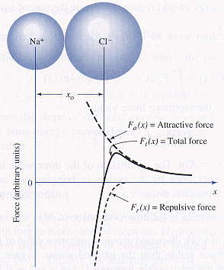 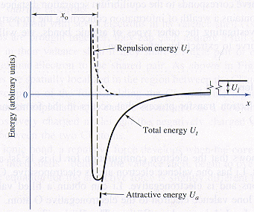 $F=\frac{dE}{da}$

**Ionic bonding is not directional**. What induces the structure exhibited by CsCl with its coordination number CN = 8 is simply **space** **filling**, the packing of small cations and large anions to preserve charge neutrality at highest density. At specific **ratios of ionic radii** the coordination numbers of ionic solids **change**. The structure of CsCl is therefore considered **a consequence of packing geometry, not bond directionality**. During charge transfer, cations decrease in size, and anions increase in size, imposing a size effect on how they can pack together in solid state. This packing geometry is limited by the radius ratio, and the resulting CN, influencing the development of crystal structure in ionic solids.

Van der Waals bond form in polyethylene by the **dipolar** **attraction** between adjacent chains or coiled/folded segments of the same chain. The **positively charged portions of the chain populated by hydrogen and negatively charged portions of an adjacent chain between the hydrogen atoms are attracted to one another**. The function of such a bond is to give strength to the structure, enough to sustain a solid phase but not strong enough to withstand even a small temperature rise, which causes severe softening of the structure, and a relatively low meting temperature.

|  |  |
| --- | --- |
|  | 8 \* 1/8 atoms on the corner: 0,1  6 \* 1/2 atoms on the face: 1/2  4\*1 atoms on tetrahedral interstices: 1/4, 3/4  The lattice direction connecting he atoms at locations 1,0,0 and 1/4, 1/4, 1/4 is sketched here. Its index is obtained by shifting the origin to 1,0,0 and subtracting from 1/4, 1/4, 1/4, to obtain the new location, -3/4, 1/4, 1/4, relative to the new origin. Clearing fractions yields the lattice direction [$\overline{3}$ 11]. The family of planes containing the lattice direction is shown by constructing parallel lines through all of the atom positions and noting the smallest d-spacing that results. They are indexed by the fractional intercepts, which, from the origin (upper left point), are 1/2 along the x-axis, generating the Miller indices (260). The normal to these plane is the [260] direction, confirmed by dot product with the [$\overline{3}$ 11] direction to be the correct index. |
|  | The simple hexagonal Bravais lattice has lattice points at all locations labelled 0,1 on this projection, which are the corners of the unit cell. The motif must be associated with each and every lattice point, requiring a three-atom assignment, one C atom at 0,0,0, one W atom at 2/3, 1/3, 1/4, and ne W atom at 1/3, 2/3, 3/4. A simple hexagonal unit cell is primitive, so it contains a single lattice point. Every lattice point ontains one C atom and two W atoms. Consequently, the complete contents of the unite cell is C atom and 2 W atoms. One C atom is shared by all corners with adjacent cell, and two W atoms are fully contained within the cell. |

**Lattice**- an array of points in space (a mathematical construction) with identical environment

**Motif**- assignment of atoms or ions to each and every lattice point in exactly the same way

|  |  |  |  |  |
| --- | --- | --- | --- | --- |
| **The 7 lattice systems** | **The 14 Bravais lattices** | | | |
| [Triclinic](http://en.wikipedia.org/wiki/Triclinic) | PCC |  | BCC | FCC |
| [Triclinic](http://en.wikipedia.org/wiki/File:Triclinic.svg) |  |  |  |
| [Monoclinic](http://en.wikipedia.org/wiki/Monoclinic) | [Monoclinic, simple](http://en.wikipedia.org/wiki/File:Monoclinic.svg) | [Monoclinic, centred](http://en.wikipedia.org/wiki/File:Monoclinic-base-centered.svg) |  |  |
| [Orthorhombic](http://en.wikipedia.org/wiki/Orthorhombic) | [Orthohombic, simple](http://en.wikipedia.org/wiki/File:Orthorhombic.svg) | [Orthohombic, base-centred](http://en.wikipedia.org/wiki/File:Orthorhombic-base-centered.svg) | [Orthohombic, body-centred](http://en.wikipedia.org/wiki/File:Orthorhombic-body-centered.svg) | [Orthohombic, face-centred](http://en.wikipedia.org/wiki/File:Orthorhombic-face-centered.svg) |
| [Tetragonal](http://en.wikipedia.org/wiki/Tetragonal) | [Tetragonal, simple](http://en.wikipedia.org/wiki/File:Tetragonal.svg) | [Tetragonal, body-centred](http://en.wikipedia.org/wiki/File:Tetragonal-body-centered.svg) |  |  |
| [Rhombohedral](http://en.wikipedia.org/wiki/Rhombohedral_lattice_system) | [Rhombohedral](http://en.wikipedia.org/wiki/File:Rhombohedral.svg) |  |  |  |
| [Hexagonal](http://en.wikipedia.org/wiki/Hexagonal_lattice_system) | [Hexagonal](http://en.wikipedia.org/wiki/File:Hexagonal_lattice.svg) |  |  |  |
| [Cubic](http://en.wikipedia.org/wiki/Cubic_%28crystal_system%29) | [Cubic, simple](http://en.wikipedia.org/wiki/File:Cubic.svg) |  | [Cubic, body-centred](http://en.wikipedia.org/wiki/File:Cubic-body-centered.svg) | [Cubic, face-centred](http://en.wikipedia.org/wiki/File:Cubic-face-centered.svg) |

hkl denotes a lattice position, a point on the lattice

[hkl] denotes a lattice direction, the vector that connects the origin to hkl position.

Direction [uvw] and [u’v’w’], the angle between them is $\arccos{\frac{uu^{'}+vv^{'}+ww'}{\sqrt{u^{2}+v^{2}+w^{2}\sqrt{{u'}^{2}+{v'}^{2}+{w'}^{2}}}}}$

<hkl> denotes the family of directions

|  |  |
| --- | --- |
| http://upload.wikimedia.org/wikipedia/commons/thumb/d/d5/Miller_Indices_Felix_Kling.svg/300px-Miller_Indices_Felix_Kling.svg.png | (hkl) denotes a plane, the integer reciprocal of the intercepts to each planes (xyz). If the plane goes through the origin, select an equivalent plane or move the origin.  Planes and their negatives are equivalent.  In the cubic system, a plane and a direction with the same indices are orthogonal.  {hkl} denotes the set of all planes that are equivalent to (hkl) by the symmetry of the lattice  Planes: (hkl) becomes (hkil), where h + k = -i  Directions: [UVW] becomes uvtw  u = (2U-V)/3, v= (2V-U)/3, t = -(U+V), w = W  U = u-t, V = v-t, W = w |
| the scattering condition is established to mimic reflection from the diffracting planes, so the incident angle is equal to the diffraction angle. | |  |  |  |  | | --- | --- | --- | --- | | Crystal structure | Diffraction doesn’t occur when | Diffraction occurs when | First few peaks | | Bcc | h+k+l = odd | h+k+l = even | 110 200 211 220 310 222 | | Fcc | h,k,l both even and odd | h,k,l all even or all odd | 111 200 220 311 222 400 | | hcp | H+2k = multiple of 3  l = odd | Any other cases |  | |

**Point Defects**

|  |  |  |
| --- | --- | --- |
| http://upload.wikimedia.org/wikipedia/commons/thumb/c/c1/Nacllattice.svg/220px-Nacllattice.svg.png  Defect-free NaCl | http://upload.wikimedia.org/wikipedia/commons/thumb/0/05/Naclschottkydefect.svg/220px-Naclschottkydefect.svg.png  Schottky defect/pair (vacancy) | http://upload.wikimedia.org/wikipedia/commons/thumb/8/86/Naclfrenkeldefect.svg/220px-Naclfrenkeldefect.svg.png  Frenkel defect/pair (interstitial)  It has an extended strain field |

Vacancies in solids participate in diffusion and increase the entropy of the material. There is a collapse into the gap by all contiguous atoms, which in turn stretch their bonds to the nearest neighbors, the equivalent response to a tensile load. So the strain field is “tensile”.

The creation of a single vacancy in hcp structure requires the breaking of 6 bonds. Two isolated vacancies therefore have 12 broken bonds, but a single divacancy has only 10 broken bonds. The energy difference makes the divacancy more favorable.

|  |  |
| --- | --- |
| **Linear Defects- Dislocations (participate in plastic deformation)**  **Burger’s vector-** the displacement vector necessary to close a stepwise loop around the defect point.    If dot product of the line direction vector and the Burger’s vector = 0, they are perpendicular, then this is an edge dislocation. The slip plane can be calculated by taking the vector cross product of the dislocation line vector and Burger’s vector. The slip plane must contain the burger’s vector. Slip direction is always given by the Burger’s vector. Slip plane dot Burger’s vector must = 0 | Filled are the atoms comprising the extra half-plane. Edge dislocation and dislocation line.    Burger’s vector and burger’s circuit (must enclose the dislocation line)  finish-start-right hand (FSRH) convention |
|  | Slip doesn’t occur simultaneously everywhere across the slip plane. Yielding must occur a bit at a time till it has occurred all over the slip plane. Bonds across the slipping planes are broken and remadein succession. The line that separates the slipped and unslipped region is the dislocation. |

**Cold working**

Cold work induces defects. And deformation is the motion of defects, or dislocation motion. The more defects there are, the harder it is for these defects to move. A cold-worked material is harder and stronger. Cold working increases fatigue strength by inhibiting crack invitation. Cold working decreases the T at which recrystallization occurs by creating dislocations and sites for recrystallization.

**Three stages of annealing**

* **Purpose:** to remove damage from cold work
* requires elevating temperature to enable diffusion, 1/3 to 1/2 of the melting temperature
* annealing to the point of excessive grain growth can soften the material

|  |  |
| --- | --- |
| fg10_34 | 1. **Recovery**  * Annihilation of point defects * Dislocation **polyganization** (subgrain boundaries)   + Since low T of the dislocations are more mobile, they tend to pile up to lower the strain energy of the system   + the arrangement of excess dislocations into low angle tilt boundaries (misorientations of a few degrees).   + leads to the formation of sub-grains * Driven by reduction in strain energy  1. **Recrystallization**    * Driven by reduction in strain energy    * Crystallization reaction of new strain-free grains that consume the little heavily dislocated grains behind them 2. **Grain growth**  * Driven by reduction in surface energy |

Strength on a microstructural scale is resistance to the nucleation and migration (slip) of dislocations. Grain boundaries act as barriers to dislocation motion by disrupting the continuity of slip planes; the more grain boundaries appearing in the path of mobile dislocations, the greater the number of impediments to their motion. Consequently, fine grained microstructures with their higher density of grain boundaries resist dislocation motion more than coarse grain microstructures.

**Volume defects-** Inclusions- MnS in steel Dispersed particles- Al2O3 in Al Voids and cracks

**Creep deformation**

|  |  |
| --- | --- |
| File:3StageCreep.svg | **Primary**- the strain rate is relatively high, but slows with increasing time due to work hardening.  **Secondary**- the strain rate reaches a minimum and becomes near constant, due to the balance between work hardening and annealing.  **Tertiary**- the production of dislocations is too significant. The strain rate increases exponentially because of necking.  Grain boundary sliding will be aggravated by more grain boundaries, offering a larger interfacial area over which sliding can occur. Since small grained materials have larger grain boundary area, they are more likely to suffer creep. Therefore it is more desirable to design creep-resistant ceramics having larger grains. |

**Phases and components**

**Phase**- physically distinct, homogeneous, body of matter with definable boundaries

**Component**- distinct chemical constituent form which phases are formed

**Degrees of freedom**- independent variables available to a system; if varied, cause phase changes

$rate = {Ce}^{-\frac{Q}{RT}} \ln{rate }=\ln{C}-\frac{Q}{R}\frac{1}{T} for diffusion:\ln{D}=\ln{D_{0}}-\frac{Q}{R}\frac{1}{T}$ Q is the activation energy

diffusion of carbon in iron (BCC/FCC) > self-diffusion of iron in iron (BCC/FCC), **higher diffusion coefficient** (D), smaller slope (**smaller activation energy**, occurring more readily)

**carbon** diffuses **interstitially** (more rapid, lower activation energy), **iron** diffuses **substitutionally** by a **vacancy** mechanism.

Diffusion of any type in BCC structure (less densely packed, lower activation energy) occurs more readily than in FCC structure.

|  |  |
| --- | --- |
| **Inter-diffusion** | **Self-diffusion** |
| Substitutional diffusion | Interstitial diffusion    Interstitial atoms are smaller and more mobile. More empty positions than vacancies |
|  | |

Commercial wires are polycrystalline, full of grain boundaries, and these grain boundaries serve as high diffusivity paths, especially prominent at low T. Diffusion at high T is very fast, fast enough to be competitive with grain boundary diffusion. Extrapolating this data to low T on the assumption that all diffusion occurs through the bulk rather than through defects rendered a very low calculated diffusion flux. But at low T, grain boundary diffusion can be orders of magnitude faster than volume diffusion.

**Gibbs Phase Rule**, F = C – P + 2 F = C – P + 1 for fixed pressure (typically the case)

|  |  |  |  |  |
| --- | --- | --- | --- | --- |
| **Hume-Rothery rules**  Atomic size effect (<= 15% difference in atomic radii)  Structure effect (same Bravais lattice, same crystal structure)  Electronegativity effect (attraction for electrons)  Valency effect (same oxidation state) | | | C = 1 on two ends of the phase diagram. C = 2 anywhere else  P = 1 in one phase region (liquid, apha, beta, gamma, etc.)  P = 2 in two phase region | |
| http://upload.wikimedia.org/wikipedia/commons/thumb/8/8e/Lever_rule.svg/400px-Lever_rule.svg.png |  | |  | |
|  | |  | |

**Eutectic system**

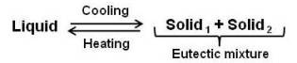

|  |  |
| --- | --- |
|  | Solidification of Alloy 1 |

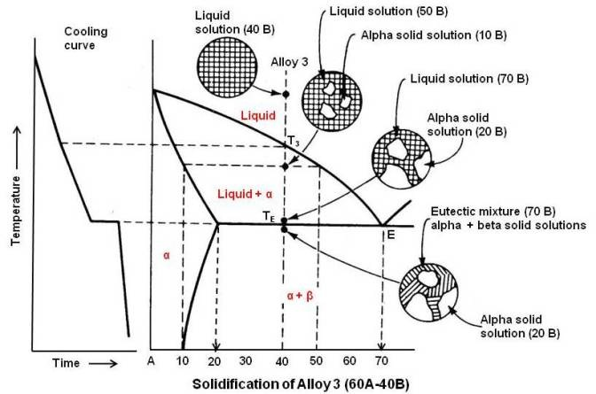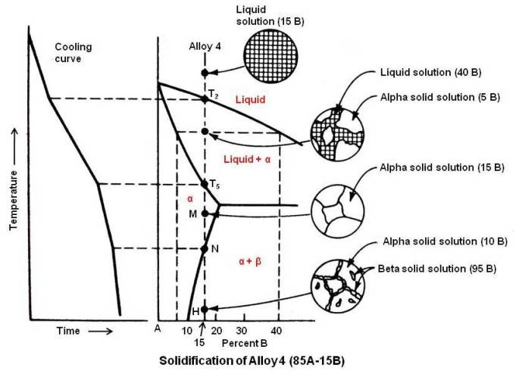

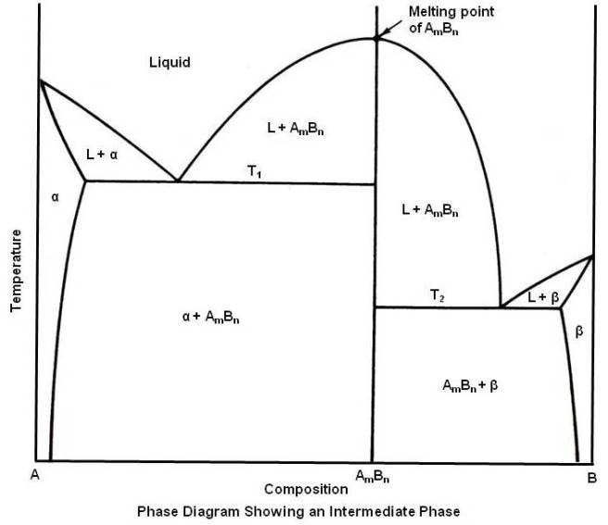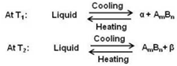

**Peritectic reaction**  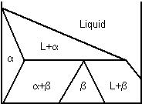 L + alpha 🡪 beta 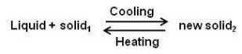

**Peritectoid reaction** 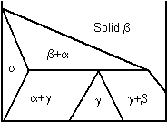 alpha + beta 🡪 gamma 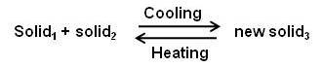

**Eutectoid reaction** 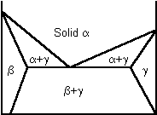 alpha 🡪 beta + gamma 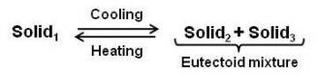

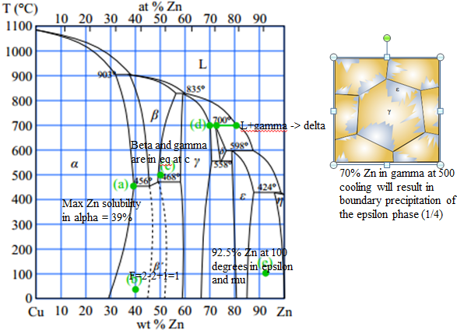 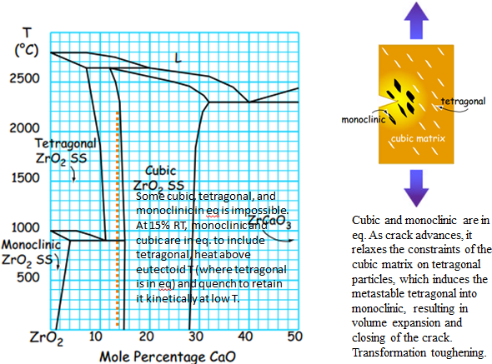

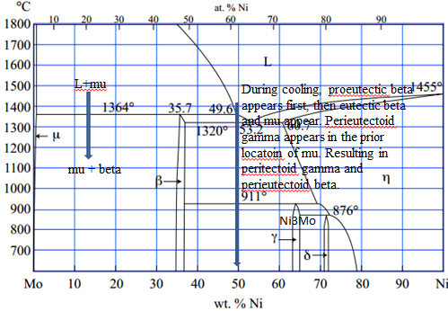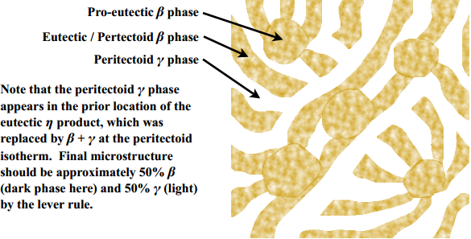

**Facts about steel**

* Crystalline as a consequence of metallic bonding
* Alloy of Fe and C, but iron doesn’t form molecules with C, no secondary bonding, only primary bonding
* Bravais lattice with Fe atoms on lattice sites and C atoms located interstitially between lattice sites
* Cementite is not a molecule, but one of the solid phases found in steel
* Micro constituent phases of steel are products of primary bonds, sometimes purely metallic and sometimes mixed metallic and covalent character.

The hardness and malleability of steel depends not only on the carbon content, but also prior austenite grain size, amount and distribution of micro constituent phases, and dislocation content.

|  |  |  |  |  |
| --- | --- | --- | --- | --- |
|  | | | Coarse pearlites are formed at high temperatures and are generally softer, because the grain size is big, allowing for more defect motion. At high temperatures the supersaturation is low, so the driving force for the emergence of new phase is low, causing fewer nuclei, but since diffusion is favored, the few nuclei grow very quickly. The result is a coarse microstructure.  Fine pearlites are formed at low temperatures and are generally harder, because the grain size is small, allowing for less defect motion. At low temperatures supersaturation is high, generating a high driving force and nucleation, but since diffusion is hindered, growth is hindered, resulting in a fine microstructure. | |
|  | | quench to 650 and wait (at least 20 s) to form coarse pearlite  quench to 500 and wait (at least 10 s) to form fine pearlite (soft and ductile)  quench to 350 and wait (at least 1000 s) to form bainite (fine needles)  quench to room temperature to form martensite immediately  to create X% martensite, Y% fine pearlite, Z% bainite  quench to 500 and wait to transform Y% of austenite to fine pearlite  quench to 350 and wait and transform Z/(1-Y%) of remaining austenite to bainite  quench remaining to marteniste | | |
| http://www.gowelding.com/met/carbon1.gif | | Carbon is soluble in the FCC phase of Fe (austenite or gamma-Fe) up to 2%  Carbon is soluble in the BCC phase of Fe (ferrite or alpha-Fe) up to 0.02%  When austenite is cooled below 727 the eutectoid T, it becomes unstable. The transformation of austenite requires redistribution of C atoms from a random solid solution to one in which all C is contained in the Fe3C precipitates. Just below eutectoid T, the driving force is low. The lower T, the greater the driving force, causing a higher nucleation rate. Below 540, the rate of transformation decreases again because C atoms become less mobile in austenite. If FCC austenite is quenched, it changes instantly by a shear mechanism to a BCT structure, trapping C in martensite. | | |
| **austempering** | **martempering** | | | **Interrupted quench** |
| Tempering is a low T thermal treatment to restore some ductility by allowing carbon diffusion, precipitation of carbides, and restoration of a cubic structure with more slip systems than the tetragonal martensitic structure, allowing the final part to withstand even aggressive impact loading. | | | | |

**Thermal treatment**

* thermal shock is a consequence of: **thermal expansion** (alpha = 1/L \* dL/dT**) and thermal conductivity** (dQ/dt =-kA dT/dx)
* **differential thermal expansion** between **surface** and **interior** leads to failure of a component placed in a steep T gradient
* differential because poor thermal conductivity which prohibits heat flow that would flatten the T gradient
* **by reducing the T gradient** from **surface** to **interior**, we **slow thermal contraction at the surface** and **reduce thermal contraction at the surface relative to the interior**.
  + placing hot glassware on a dry potholder **retains heat at the surface**, reducing the T gradient from surface to interior
  + never putting glassware directly on a burner or under a broiler **separates the glassware from the high heat source**, reducing the T gradient from surface to interior.
  + allowing the oven to fully preheat before placing the glassware in the oven **immerses the glassware in a high T** environmentrather than allowing it slowly heat as the oven T increases, increasing the T gradient from surface to interior

|  |  |
| --- | --- |
| **sintering,** full density requires:   * high pressure to increase contact between particles and high T to enhance diffusion kinetics * long times in the sintering furnace to complete the densification process * grain refiners (chemical agents that “pin” grain boundaries to restrict rapid grain growth) | **sintering to produce porous materials**   * large particle size- the size of pore scales with the initial particle size * no compaction- the pores will remain open longer throughout the firing process * low sintering T- the less diffusional bonding will occur, generating necks between sintered particles as needed for strength, but preserving adequate pore volume * short sintering time- diminishes the chance for pore closure |

**Failure of engineering materials**

$K_{IC}=\sqrt{πa}σ_{f} \left(fracture stress\right) K_{IC}$ is stress-intensity factor; a is crack length.

**Metallic alloys deform by dislocation motion**. **Large grains offer few barriers to dislocation**, enable metallic alloys to deform readily, raising the amount of stress that can be accommodated before fracture. **Larger grains = larger KIC**

**Ceramics do not deform by dislocation motion**, but can accommodate some stress by microcracks before failure. **Small grains** enable more microcracks along weaker grain boundaries that can dissipate failure by **crack deflection and effective crack blunting (microcrack toughening)**. **Smaller grains = larger KIC**

**A fatigue crack initiates when dislocations intersect the free surface**. To initiate a surface crack, dislocation motion is required.

**Glass ceramics are aged to precipitate a crystalline phase.**

$$σ_{m}\left(maximum stress at the tip of a crack of length\right)=2σ(tensile stress)\sqrt{\frac{a (crack length)}{p (crack tip radius)}}$$

Microcracks in ceramic materials dissipate the energy release during **crack growth by dispersing the fracture over many internal sites**. Moreover, when the primary crack joins up with the microcracks ahead of it, the primary crack is blunted, **increasing the crack tip radius**, reducing the maximum stress at the crack tip.

|  |  |
| --- | --- |
|  | **Homogenous nucleation**- precipitation occurs within a completely homogenous medium, precipitation of a single-phase solid within a liquid matrix  **Heterogeneous nucleation**- precipitation occurs at some structural imperfection such as a foreign surface  total rate of forming solid is product of **nucleation rate (favored at low T) and growth rate (favored at high T)**  transformation rate from nucleation and growth rates |

**In terms of strength:**

|  |  |
| --- | --- |
| Solution-treated, artificially aged, cold worked  Solution-treated, cold worked, naturally aged  Solution treated, artificially aged  Strain-hardened  Strain-hardened + annealed | Solution treatment enhances strength  Artificially aged > naturally aged  Cold work enhances strength  Annealing softens the material |
| **Strengthened by**  Cold working  Alloying  **Phase transformations** – precipitation hardening, carefully controlled thermal treatments, beginning with homogenization in a single phase field, followed by a rapid quenching to generate a supersaturated solid solution, finishing with an aging treatment to produce a fine dispersion of second phase particles that impede dislocation motion | **Weakened by**  Porosity (casting)  Annealing  Welding  **Phase transformation** – not carefully controlled thermal treatments, slow cooling from the homogenization temperature, detrimental distribution of second phase particles occurring exclusively at grain boundaries. There are no precipitate particles and solute atoms. serve as obstacles to dislocation motion. |

**Work hardening** generates a high density of dislocations. Subsequent age hardening employs an elevated T to encourage diffusion and precipitate growth, but the precipitates are most likely to **nucleate heterogeneously** on the existing dislocations, **reducing precipitate density** and dispersion compared to a homogenously-nucleated product. Moreover, diffusion will also cause some annealing, removing some of the original dislocations in the microstructure.

**Age hardening** in the absence of dislocations generates a **homogenously-nucleated product with high density and uniform dispersion**. Subsequent work hardening adds dislocations to the microstructure that are themselves pinned by the existing precipitate dispersion. The stronger alloy results from **age hardening because of its overall higher density of obstacles.**

**Precipitation Hardening** is a heat treatment in which the strength of an alloy is increased from introducing particles that act as obstacles to slip motion. Not all alloy systems are amenable to this strengthening mechanism. The alloy system must have:

1. a terminal solid solution with decreasing solid solubility as temperature decreases
2. 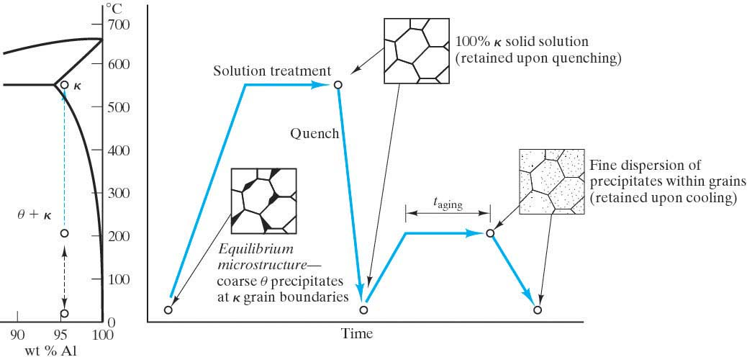a second phase that will act to impede the dislocation motion.

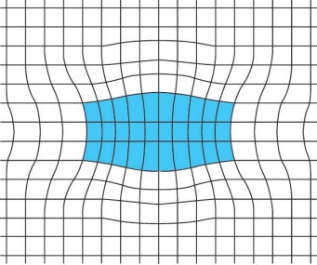

**The procedure to produce the microstructure of a precipitation hardened alloy is:**

1. **Solution Treat** (Solutionize) - Heat to the point where you have a single phase solid solution.
2. **Quench -** To get a metastable super-saturated solid solution.
3. **Age (Precipitation heat-treat) -** Heat at an intermediate temperature such that diffusion is appreciable for an appropriate amount of time in order to precipitate out the second phase particles. The nature of these second phase precipitates depend on the time and temperature of the aging process. You want the second phase particles to be of optimal size to produce the maximum obstacle to slip motion. This turns out to be when the size of the precipitate is such that the crystal structure of the precipitate and the matrix phase are coherent.
4. **Cool**

**Be careful:**

1. Do not **overage.** (When ppts grow to a size where they do not add significant strength.)
2. Do not put the material in an application where temperature may overage it.
3. Be careful of natural aging (aging that can occur at room temperature. (As opposed to artificial aging which is when the material is inadvertently put at an elevated temperature.)

|  |  |  |  |  |  |  |  |
| --- | --- | --- | --- | --- | --- | --- | --- |
|  | Soft, viscous flow form, lying flat. No stress. | | | | | When the glass is too hot, its surface cannot be cooled below Tg during the surface quench. The surface will not be in temporary tension but will readily deform to **relax all stress gradients**. As the glass cools slowly to RT, all of it passes through Tg at the same time, again relaxing all stress gradients. No compression on surface, no interior tension, no residual stress. | |
| Below Tg, both surfaces cool (but interior is still hot). Surface contracts while interior expands.  Interior is in compression (squeezed).  Exterior is in tension (pushed outwards). | | | | |
| After surface cooling, interior starts to cool, but surface wants to maintain its position because it’s already cool.  Interior is in tension (pushed outwards by surface).  Exterior is in compression (squeezed by interior contraction). | | | | |
|  | | | | | |  | |
| **Blockcopolymers**  –AAAAABBBBBBBAAAAA  –sequences or blocks of each monomer | | | | **Graft copolymers**  –blocks of one monomer are grafted as branches onto the other  –AAAAAAAAAAAAA  B B  B B | | | |
|  | | | | At low T, ABS has a higher elastic modulus than PC because of the acrylonitrile and styrene grafts extending off butadiene backbone, colliding with one another and obstructing the relative motion of ABS chains past during elastic deformation. PC has much less steric hindrance because it has no such extensions protruding from the backbone chain.  Increasing T: diffusional motion enables the grafts to more easily evade one another during uncoiling and sliding, generating a lower Tg in ABS than PC. Interpenetration of chains from PC and ABS constituents increased rigidity and resistance to chain uncoiling and sliding. | | | |
| Isotactic - same side | | Syndiotactic – alternating | | | | | Atatic – random |
| **Condensation**   * Molecules join by losing a molecule * step growth * monomers with functional groups * polyesters, polyacetals, polyamides, polyurethane | | | **Addition**   * repeat unit has the same composition as the monomer * chain growth * molecules bond to form a chain, no loss * PE, PVC, PTFE, PS, PMMA, Nylon-6, PP | | | | |
|  | | | Not enough space for all 6 C on the phenol ring to simultaneously connectd to other phenols. Connecting every other C is possible, trifunctional  **Steric hindrance** | | | | |
|  | | | The double carbon bond suggests that initiation causes a bifunctional mer, leading to **chain growth by addition** polymerization up to a DOP of n. | | | | |
|  | | | Cross-linking joins mers from adjacent backbone chains by covalent bonding, **preventing any lateral sliding** of those chains past one another, **increasing rigidity and elevating the modulus at all T.**  Branching **inhibits** but doesn’t prevent the sliding.  Viscoelastic deformation  Uncoiling of chains 🡪 sliding (vdW bonds break) 🡪 stretching of covalent bonds  Glass transition temperature marks the transition from rigid “crystal-like” to viscous “glass-like” mechanical behavior. Crystals deform by dislocation motion. Glasses deform by viscous flow. At the melting point, elastic modulus drops to 0. | | | | |
|  | | | Elastic returns to original state after strain is removed.  Viscous doesn’t return to original state after strain is removed, so it is permanently deformed.  Viscoelastic recovers to original state slowly.  Elastomers and thermoplastics are readily formed into complex shapes by flow or injection molding at high T and recyclable | | | | |
| **Thermoplastic polymers**   * Plastic at T * Linear polymers * Thermal activation (Arrhenius) * Ductility reduced by coiling * recyclable | | | **Thermosetting polymers**   * set by T * network polymer * step-growth process (facilitated at high T) * not recyclable | | | | |
| http://www.daviddarling.info/images/vulcanization.png **vulcanization** | | | | | http://upload.wikimedia.org/wikipedia/commons/thumb/8/82/ABS_resin_formula.PNG/1024px-ABS_resin_formula.PNG  **ABS – acrylonitrile-butadiene-styrene** | | |

Polymers typically show no clear transition between elastic plastic deformation and no clear ultimate tensile strength (necking behavior). Deformation in polymers begins by the uncoiling and sliding of polymer chains past one another as weak secondary vdW bonds are broken. This accounts for the low strength of polymers. A dislocation model of plasticity is NOT appropriate for polymers lack crystallinity. Failure ultimately occurs when polymer chains are separated as elongation and sliding reach their physical limits.

**Molecular length**

* Root mean square length L = l $\sqrt{m}$ m is number of bonds l is length of a single bond
* Extended length $L_{ext}=ml\sin{54.75}$

|  |  |
| --- | --- |
|  | $$flexural strength=\frac{3FL}{2wh^{2}}$$ $$flexural modulus=\frac{{mL}^{3}}{4wh^{3}}$$ |

Resistivity $ρ=\frac{RA}{l} R=\frac{ρl}{A}$ $σ=\frac{1}{ρ}=n \left(the density of charger carriers\right)*q \left(the charge carried\right)*μ (the mobility)$

$$μ=\frac{\overline{v} (drift velocity)}{E (electric field strength)} σ=n_{n}q_{n}μ_{n}+n_{p}q_{p}μ_{p}$$

The Fermi function, f(E), describes the relative filling of energy levels. At 0K, all energy levels are completely filled up to the Fermi level, EF, and are completely empty above EF. At T>0K, the Fermi function, f(E), indicates promotion of some electrons above EF.

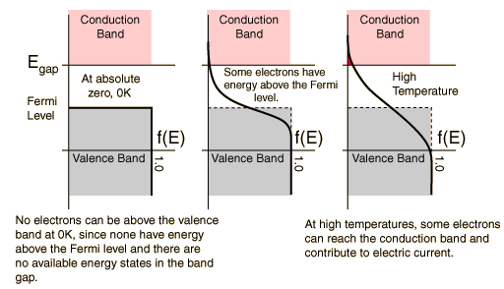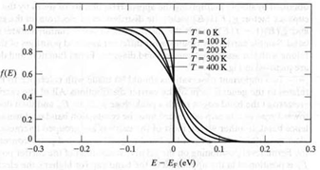

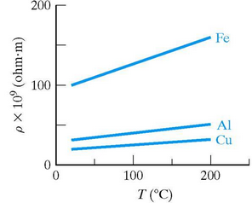

|  |  |  |
| --- | --- | --- |
| **T effects on conductors** | **Impurity effects on conductors** | **T effects on semiconductors** |
| sigma = n q m | sigma = n q m | sigma = ni q (me + mh) |
| **q (charge)** will not change | | |
| **n – number of carriers**  The electrons that are charge carriers in a conductor will gain energy and go into higher energy levels. However, these energy levels are all still in the valance band. So the number of charge carriers will not change for a conductor with an increase in temperature. | **n – number of carriers**  Nothing! So number of charge carriers will not change for a conductor with an increase in impurities. | **n – number of carriers**  The electrons in the valance band will gain energy and go into the higher energy levels in the conduction band where they become charge carriers! So this term will increase. Not only will it increase, but it will increase exponentially! (Promoting electrons from the valance band into the conduction band is a thermally activated process.)   * + ni = C e – (E – Eave)/kT   + ni = C e – Eg/2kT   So even though mobility decreases, the exponential increase in the number of charge carriers will dominate. |
| **m – electron mobility**  Recall that mobility is the drift velocity divided by the electric field strength. Temperature won't affect the electric field strength. But it will decrease the drift velocity because as the temperature increases, the atomic vibrations will increase, which will cause more collisions of the electrons with the crystal lattice. Hence the drift velocity will decrease. | **m – electron mobility**  If you consider that impurities will distort the crystal lattice, hence impeding the drift velocity, then you will see that the mobility will decrease. This is similar to the argument for the fact that mobility will decrease with an increase in temperature. | **m – electron mobility**  The effect of an increase in temperature on mobility is the same as it was for conductors. With the same reasoning, we see that the drift velocity will decrease causing the mobility to decrease. |

[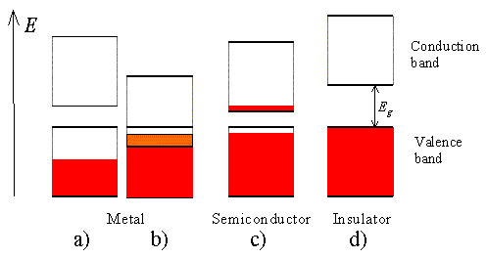](http://ecee.colorado.edu/~bart/book/book/chapter2/ch2_3.htm#fig2_3_11) 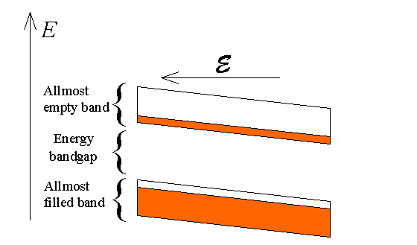

Intrinsic semiconductors are semiconductors, which do not contain impurities. They do contain electrons as well as holes. The electron density equals the hole density since the thermal activation of an electron from the valence band to the conduction band yields a free electron in the conduction band as well as a free hole in the valence band.

|  |  |
| --- | --- |
| N-type semiconductor [http://upload.wikimedia.org/wikipedia/commons/thumb/8/8b/N-Type_Semiconductor_Bands.svg/200px-N-Type_Semiconductor_Bands.svg.png](http://en.wikipedia.org/wiki/File:N-Type_Semiconductor_Bands.svg)the electrons are the majority charge carrier. | P-type semiconductors [http://upload.wikimedia.org/wikipedia/commons/thumb/3/37/P-Type_Semiconductor_Bands.svg/200px-P-Type_Semiconductor_Bands.svg.png](http://en.wikipedia.org/wiki/File:P-Type_Semiconductor_Bands.svg) the holes are the majority charge carrier. |
| Extrinsic semiconductors with a larger electron concentration than hole concentration are known as n-type semiconductors. In n-type semiconductors, electrons are the majority carriers and holes are the minority carriers. N-type semiconductors are created by doping an intrinsic semiconductor with donor impurities. A common dopant for n-type silicon is phosphorus. In an n-type semiconductor, the Fermi level is greater than that of the intrinsic semiconductor and lies closer to the conduction band than the valence band. | **Extrinsic semiconductors** with a **larger hole concentration than electron concentration** are known as**p-type semiconductors**. In p-type semiconductors, **holes are the majority carriers and electrons are the minority carriers**. P-type semiconductors are created by doping an intrinsic semiconductor with acceptor impuritie. A common p-type dopant for silicon is boron. For p-type semiconductors the Fermi level is below the intrinsic Fermi level and lies closer to the valence band than the conduction band |
|  |  |
|  |  |

Compound semiconductors look like group IV A elements “on the average”

III-V compounds are MX compositions with M being a 3+ valence elements X being a 5+ valence element.

II-VI compounds are MX compositions with M being a 2+ valence elements X being a 6+ valence element.

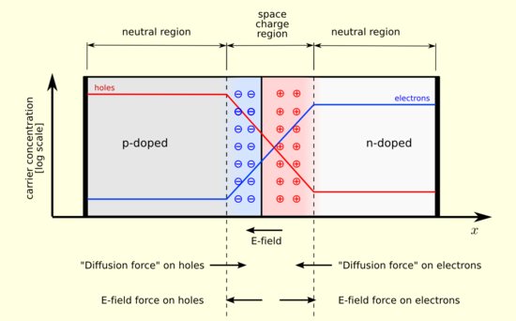 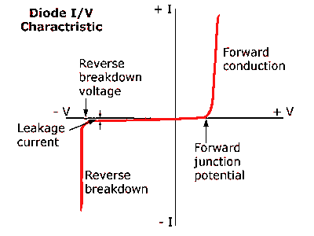

|  |  |
| --- | --- |
| http://www.ibiblio.org/kuphaldt/electricCircuits/Semi/03409.png | |
| In forward bias, electrons flow from the electrode to the n-type, foring electrons in the n-type flow to the junction. Holes from the p-type flow to the junction. Electrons and holes are continuously recombined. This process allows a continuous flow of current in the overall current. | In reverse bias, electrons flow from the electrode to the p-type, attracting holes in the p-type away from the junction towards the electrode, and attracting electrons in the n-type from the junction towards the electrode. Polarization occurs and little current flow. |

|  |  |
| --- | --- |
| http://upload.wikimedia.org/wikipedia/commons/thumb/3/36/PNP_BJT.svg/400px-PNP_BJT.svg.png | http://info.tuwien.ac.at/theochem/si-srtio3_interface/mosfet.jpg |
| Junction1 (between the emitter and base) is forward biased. It looks identical to the rectifier. However, the recombination of electrons and holes do not occur immediately. Many of the charge carriers move well beyond the junction. If the base (n-type) is arrow enough, a large number of the holes (excess charge carriers) pass across junction 2. Once in the collector, the holes again move freely (as majority charge carriers). The transistor is an **amplifier**, since slight increases in the emitter voltage can produce dramatic increases in collector current. | **Field-effect transistor (FET)** incorporates a channel between a source (emitter) and a drain (collector). The p-channel becomes conductive upon application (under an insulating layer of silica). The channel’s field, which results from the negative gate voltage, produces an attraction for holes from the substrate. The result is the free flow of holes from the p-type source to the p-type drain. The removal of the voltage on the gate effectively stops the current. |

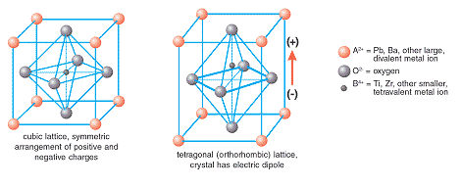

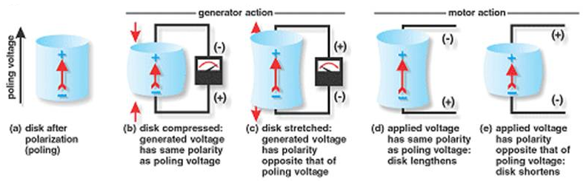

|  |  |  |
| --- | --- | --- |
| Dielectric polarization  http://upload.wikimedia.org/wikipedia/commons/thumb/7/74/Dielectric_polarisation.svg/160px-Dielectric_polarisation.svg.png | Paraelectric polarization  http://upload.wikimedia.org/wikipedia/commons/thumb/2/27/Paraelectric_polarisation.svg/160px-Paraelectric_polarisation.svg.png | Ferroelectric polarization  http://upload.wikimedia.org/wikipedia/commons/thumb/f/f3/Ferroelectric_polarisation.svg/160px-Ferroelectric_polarisation.svg.png |

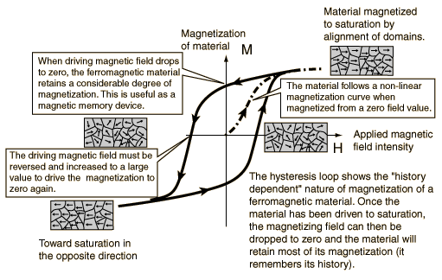

|  |  |  |  |  |  |
| --- | --- | --- | --- | --- | --- |
| **Composite Materials**   Composite materials are mixtures of two or more components which are essentially insoluble in each other. The components are usually taken from the fundamental structural materials: metals, ceramics, glasses, polymers.  The properties of composite materials will be determined by the constituents, their relative amounts and the geometry of how they are put together. The result is a material that has superior properties to any of the constituents alone: "The best of both worlds." | | | | | |
| **Aggregate Composites**  More or less equi-axed particulates embedded in a matrix material | | **Fiber-reinforced Composites**  Axial particulates embedded in a matrix material | | | **Structural Composites**  Composites with sophisticated geometries |
| **Dispersion Strengthened**  The particulates are small in size and are present in small concentrations. (<15%) .  The strength comes from the particulates impeding dislocation motion.  Examples include:   * **TD Nickel**   Thoria (TO2) dispersed in Ni matrix   * **SAP**   Sintered Aluminum Powder, alumina (Al2O3) coated Al particles dispersed in an Al matrix   * **Al2O3 in Cu**   Alumina particles dispersed in a copper matrix   * **Al2O3 in Fe**   Alumina particles dispersed in an iron matrix | **Particulate Composites**  The particulates are relatively large and are present in large concentrations. (>25% and typically between 60-90%)  The strength comes from particulates restraining the matrix movement in the vicinity of the particulate.  Examples include:   * **concrete** * **asphalt** * **cements** * ceramic particles in a metal matrix such as  tungsten carbide in cobalt(WC/Co) used for a cutting tool * **carbon black rubber**   carbon black in a rubber matrix used for tires | **Aligned Fibers**  These are either continuous (long) or discontinuous (short).  These composites will be highly anisotropic with higher strength in the direction of the fibers.  Continuous fibers make a stronger composite, but are more expensive and difficult to fabricate.  Examples include:   * fiberglass * wood | **Randomly Chopped Fibers**  These are randomly oriented short fibers.  They are cheaper and easier to fabricate, however, their properties are usually inferior to that of aligned fiber composites. | **Woven Fibers**  These fibers are woven in a fabric that is then layered with a matrix material to form a laminate.  More expensive but with superior properties. | Examples include:  **sandwich panels**  These are made by sandwiching a less dense core material between two thin, strong outer layers.  The core, although not as stiff or strong as the outer layers provides resistance to deformations perpendicular to the faces, and shear rigidity along planes perpendicular to the face.   * **Laminates**   These are made by 2-dimensional sheets or panels that have a preferred high strength direction.  The layers are stacked and cemented together. |

**Fiber Geometry**

|  |  |
| --- | --- |
| **Aligned**  The properties of aligned fiber-reinforced composite materials are highly anisotropic. The longitudinal tensile strength will be high whereas the transverse tensile strength can be much less than even the matrix tensile strength.  It will depend on the properties of the fibers and the matrix, the interfacial bond between them, and the presence of voids.  There are 2 different geometries for aligned fibers:   * 1. **Continuous & Aligned**   The fibers are longer than a critical length which is the minimum length necessary such that the entire load is transmitted from the matrix to the fibers. If they are shorter than this critical length, only some of the load is transmitted. Fiber lengths greater that 15 times the critical length are considered optimal. Aligned and continuous fibers give the most effective strengthening for fiber composites.   * 1. **Discontinuous & Aligned**   The fibers are shorter than the critical length. Hence discontinuous fibers are less effective in strengthening the material, however, their composite modulus and tensile strengths can approach 50-90% of their continuous and aligned counterparts. And they are cheaper, faster and easier to fabricate into complicated shapes. |  |
| **Random**  This is also called discrete, (or chopped) fibers. The strength will not be as high as with aligned fibers, however, the advantage is that the material will be istropic and cheaper. |  |
| **Woven**  The fibers are woven into a fabric which is layered with the matrix material to make a laminated structure**.** |  |

**Structure of Wood**

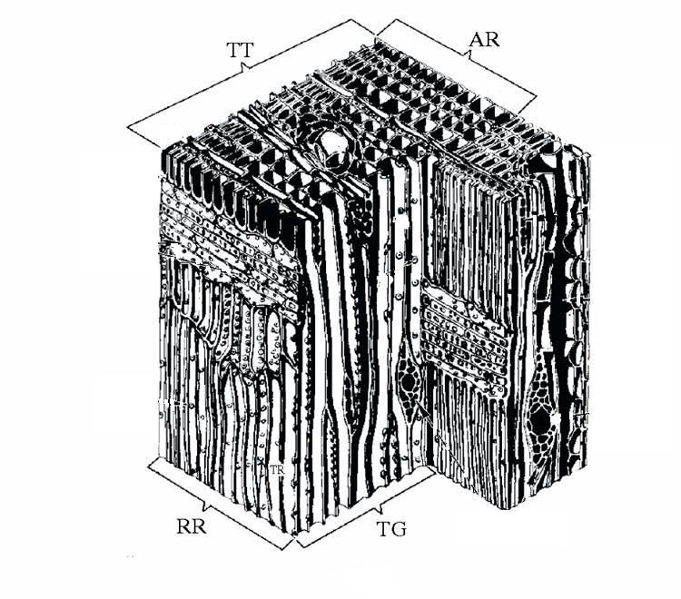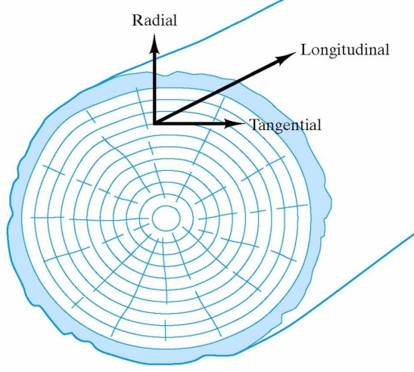

|  |  |
| --- | --- |
| The structural features are:   * TT is a cross-sectional face * RR is a radial face * TG is a tangential face * AR is an annual ring | **Wood is Anisotropic**  Wood is highly anisotropic. The properties will be different in the radial, longitudinal and tangential directions. For example:   * Wood's tensile strength is much greater in the direction parallel to the tree stem (longitudinal direction). * Wood's compressive strenght parallel to the grain (tangential direction) is higher than that perpendicular to the grain (radial direction) by a factor of about 10 because covalent bonds act in the longitudinal direction whereas hydrogen bonds act in the direction perpendicular to the grain. |

**Interfacial Strength**

The interfacial strength refers to the strength of the bond between the matrix phase and the dispersed phase. Usually interfacial strength is desired.

**Interfacial Strength in PMCs and MMCs**

In polymeric matrix and metal matrix composites high interfacial bonding is desirable so that the stress can be transmitted from the matrix phase to the dispersed phase in order to maximize the overall composite strength. (The dispersed phase is usually the stronger material.) If the bond between the matrix phase and the dispersed phase is not strong enough to transmit the stress, then the reinforcing phase slips out of the matrix and the strength of the fibers will not be transmitted to the matrix.

**Interfacial Strength in CMCs**A case where interfacial strength is not desirable is the case of ceramic matrix composites. In these composites failure originates in the matrix. In order to maximize the fracture toughness for these, it is desirable to have a relatively weak interfacial bond allowing the fibers to pull out.  As a result, a crack initiated in the matrix can be deflected along the fiber-matrix interface.  This improves fracture toughness.

|  |  |
| --- | --- |
| A matrix crack approaching a fiber in figure (a).  It is deflected along the fiber-matrix interface as shown in figure (b).  For the overall composite shown in figure (c), the increased crack path length due to fiber pullout significantly improves fracture toughness. | In figure (a) we see a matrix crack approaching a fiber. It is deflected along the fiber-matrix interface as shown in figure (b).  For the overall composite shown in figure (c), the increased crack path length due to fiber pullout significantly improves fracture toughness. |

|  |  |  |
| --- | --- | --- |
| Property average for **isostrain**  ec = em = ef= e  This of course assumes that the matrix is intimately bonded with the fibers.  A picture showing uniaxial stressing of a composite with continuous fiber reinforcement. The load is parallel to the fibers.  The load that the composite carries is the sum of the load on the fibers and the load on the matrix: $$P_{c} = P_{m} + P_{f}$$ Substitute an expression for the load, P, using the stress (P = sA): $$s_{c}A_{c} = s_{m}A_{m} + s_{f}A_{f}$$ Now substitute an expression for the stress, s, using the strain and Young's modulus (s = eE): $$e_{c}E_{c}A_{c} = e_{m}E_{m}A_{m}+ e_{f}E_{f}A_{f}$$ $$eE_{c}A_{c} = eE_{m}A_{m}+ eE_{f}A_{f}$$ Cancelling out the e and solving for Ec gives: $$E_{c} = \left(\frac{A_{m}}{A_{c}}\right) E_{m} + \left(\frac{A_{f}}{A_{c}}\right)E_{f}$$ If Vm & Vf  are volume fractions of matrix and fibers respectively, we finally have our answer: $$E_{c} = V_{m}E_{m} + V_{f}E_{f}$$ So we see that for this case of isostrain conditions, the composite modulus, Ec, is simply the weighted average of the moduli of the components.  examine the total fraction of the load carried by the fibers: $$\frac{P_{f} }{P_{c}} =\frac{{ s}_{f}A_{f}}{s_{c}A_{c}}$$ $$\frac{P_{f} }{P_{c}}=\frac{{ eE}_{f}A_{f} }{{eE}_{c}A_{c}}$$ $$\frac{P_{f} }{P_{c}} = \left(\frac{A_{f}}{{ A}_{c} }\right)\left(\frac{E_{f}}{{ E}_{c}}\right)$$ $$\frac{P_{f} }{P_{c}} = V_{f} \left(\frac{E_{f}}{{ E}_{c}}\right)$$ Since Ef >> Ec  this can be very effective. It means that the high strength fibers will carry most of the load.  For some fiberglass, the fibers can carry ~96% of the load! The ductile matrix makes this a less brittle material. | | Property average for **isostress**  sc = sm = sf= s  A slab of composite material showing uniaxial loading perpendicular to the fiber reinforcement which has same cross section as composite.  The total elongation of the composite is the sum of the elongation of the fibers plus the elongation of the matrix: $$∆L_{c} = ∆L_{m} + ∆L_{f}$$ Divide this equation by Lc :  Note: $$L_{m} =\frac{L_{c}{tL}_{m}}{L_{c}t}$$ $$L_{m} = L_{c} \left(\frac{tL_{m} }{tL_{c} }\right)$$ $$L_{m} ={ L}_{c}V_{m}$$ Solving this for Lc gives: $${ L}_{c} =\frac{L_{m}}{V_{m}}$$ Similarily we can get: $L_{c} =\frac{L_{f}}{V_{f}}$   Substituting into the above equation with these expressions for Lc gives: $$\frac{∆L_{c}}{L_{c}} = V_{m} (\frac{∆L_{m}}{L_{m}}) + V_{f} (\frac{∆L_{f}}{L_{f}})$$ $$e_{c} = V_{m}{ e}_{m} + V_{f}{ e}_{f}$$ Substituting for the strain, e, using the stress (e = s/E): $$\frac{s_{c}}{E_{c}} = V_{m} (\frac{s_{m}}{E_{m}}) + V_{f} (\frac{s_{f}}{E_{f}})$$ And since sc = sm= sf = s, we have finally: |
| 4 plots of the equation to determine a composite property with 4 different values of n: 0, 1, 1/2, -1 | l indicates the low modulus phase. h indicates the high modulus phase  n represents different geometries and will range between –1 and +1  n = +1 corresponds to isostrain. It is also the upper bound for particulate composites.  n = -1 corresponds to isostress. It is also the lower bound for particulate composites.  n =1/2 corresponds to a relatively low modulus aggregate in a relatively high modulus matrix.   “rubber balls in a steel matrix”  n = 0 corresponds to a high modulus aggregate in a low modulus matrix.   “steel balls in a rubber matrix.” | |

**Oxidation**- metallic oxides are very stable

Loss of electrons (oxidation) $M→M^{n+}+ne^{-}$

Gaining of electrons (reduction) $O_{2}+4e^{-}→2O^{2-}$

**Porous oxide 🡪 O2 in contact with the metal at all times and diffusion occurs through the pores**

Oxide forms and grows from bottom to top $\frac{dy}{dt}=c_{1} y=c_{1}t+c_{2} where y is thickness, linear growth rate$

**Protective oxides 🡪 cation diffusion**

Metal cations diffuse up to the air interface and form oxides that grows from top to bottom

**Protective oxides 🡪 anion diffusion**

Oxygen forms an anion on the interface and diffuses to the bottom and forms the oxide that grows from bottom to top

**Protective oxides 🡪 both diffusion**

Oxide thickens from middle and grows outwards by the diffusion of both metal cations and oxide anions

$$\frac{dy}{dt}=\frac{1}{y}c_{3} y^{2}=c_{4}t+c_{5}, where y is thickness, parabolic growth$$

**Pilling Bedworth ratio**

$$R_{PB}=\frac{V_{oxide}}{V_{metal}}=\frac{\frac{M_{oxide}}{d_{oxide}}}{\frac{α*M_{metal}}{d_{metal}}}=\frac{M_{oxide}d_{metal}}{α*M_{metal}d_{oxide}} where d is density and α is subscript of M_{α}O_{β}$$

RPB < 1: the oxide coating layer is too thin (porous, likely broken and provides no protective effect (e.g. Mg)

RPB > 2: the oxide coating chips off and provides no protective effect (e.g. Fe)

1 < RPB < 2: the oxide coating is passivating and provides a protecting effect against further surface oxidation (e.g. Al, Ti, Cr-containing steels).

**Corrosion-** directly dissolves into the environment

**4 components**- anode, cathode, physical contact between the anode and the cathode, electrolytes

**Anode** reaction (electrons **away**) – $M→M^{n+}+ne^{-}$**Cathode** reaction (electrons **captured**) – $M^{n+}+ne^{-}→M$

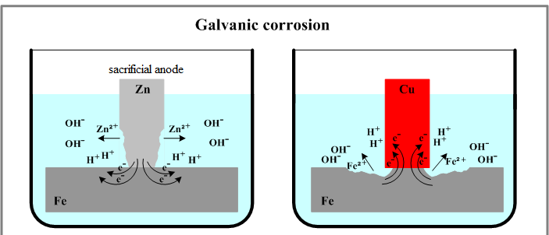

Fe steels electrons from Zn, Zn dissolves into ocean. Cu steels electrons from Fe, Fe dissolves into ocean

|  |  |  |  |
| --- | --- | --- | --- |
| http://roval-group.com/roval/common/images/p03/img_02.jpg | Noble  active | Pt  Au  C (graphite)  Cu  Brass  Ni  Steel  Al  Zn  Mg | Cathodic  anocic |

**Gaseous reduction**

**Anode** reaction (electrons **away**) – $M→M^{n+}+ne^{-}$

**Cathode** reaction (electrons **captured**) – $O_{2}+2H_{2}O+4e^{-}→4{OH}^{-}$

**Rust**

$$Fe→{Fe}^{3+}+3e^{-}$$

$$O_{2}+2H_{2}O+4e^{-}→4{OH}^{-}$$

$${Fe}^{3+}+3OH^{-}→Fe{\left(OH\right)}_{3}$$

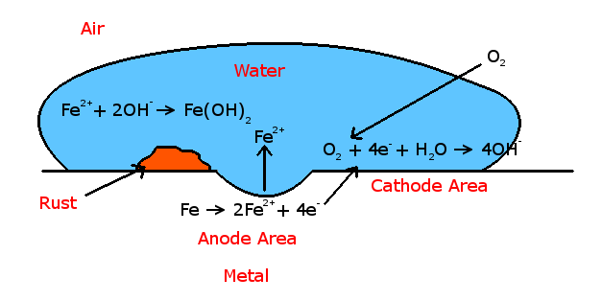

Gaseous reduction (including rust formation) is driven by an oxygen gradient. In a water pipe, the outlet is high in O2 and further inside the pipe is low in O2. So rust will form near the outlet.

**Stress-induced corrosion**- high dislocation density changes the ionization potential, which induces more corrosion.

**Prevention of corrosion**

**Materials selection**

**Design selection-** avoid large area of cathode and small area anode

**Inhibitors in electrolytes-** antifreeze inhibits water

**Protective coating**

**Sacrificial anode**

**Impressed current**- force electrons into anode (by a DC supply or a rectifier)